


Securing Federated Learning Environment

Against coordinated Data Poisoning Attacks

Pre-Graduation Project 1

Prepared by:

Maryam Yaser Alasmi Maya Hesham Daghestani

: Supervised by

Dr. Mohammed Alchaita Eng. Ahmad Shekha

2027-2026

Abstract
This research aims to analyze Federated Learning (FL) environments and investigate the mechanisms of detecting coordinated data poisoning attacks within distributed systems. While traditional robust aggregation and software-level detection algorithms can identify anomalous edge nodes, coordinating and structuring the network topology remains a fundamental prerequisite for secure model training. To address this, we establish a robust multi-node architecture utilizing a distributed star topology under VMware environments, enabling centralized aggregation and controlled communication between edge clients. The system focuses on setting up the network infrastructure, simulating client interactions, and implementing the Clique-Based Detection Framework (CBDF) to monitor weight updates and identify potential anomalies. This foundational work lays the groundwork for evaluating security threats and exploring proactive mitigation strategies in enterprise-scale federated learning systems.
Keywords: Federated Learning, Data Poisoning Attacks, Star Topology, Clique-Based Detection, Network Infrastructure, Distributed Systems.

الملخص:
يهدف هذا البحث إلى تحليل بيئات التعلم الموزع (Federated Learning) ودراسة آليات كشف هجمات تسمم البيانات المنسقة ضمن الأنظمة الموزعة. على الرغم من قدرة خوارزميات التجميع القوية وأساليب الكشف البرمجية على رصد العقد غير الطبيعية، إلا أن بناء وتنظيم طوبولوجيا الشبكة يمثل متطلباً أساسياً لتدريب النماذج بشكل آمن. ولتحقيق ذلك، نقوم بإنشاء بنية تحتية قوية متعددة العقد تعتمد على البنية النجمية الموزعة (Star Topology) في بيئات VMware، مما يتيح التجميع المركزي والاتصال المتحكم به بين العقد الطرفية. يركز النظام على إعداد بنية الشبكة، ومحاكاة تفاعلات العقد، وتطبيق إطار الكشف القائم على الزمر (CBDF) لمراقبة تحديثات الأوزان وتحديد الحالات الشاذة المحتملة. تضع هذه العمليات الأساسية حجر الأساس لتقييم التهديدات الأمنية واستكشاف استراتيجيات التخفيف الاستباقية في أنظمة التعلم الموزع على مستوى المؤسسات.
الكلمات المفتاحية: التعلم الموزع (Federated Learning)، هجمات تسمم البيانات، البنية النجمية، الكشف القائم على الزمر، البنية التحتية للشبكة، الأنظمة الموزعة.

Chapter One: Introduction

This chapter introduces the project “Securing Federated Learning Environments Against Coordinated Data Poisoning Attacks”. It presents the scientific background, reviews the related studies, defines the research problem, outlines the proposed solution, and states the objectives, the significance, and the structure of the report.

1.1 Background
Federated Learning (FL) has emerged as a groundbreaking concept for training machine learning models over decentralized datasets, enabling multiple clients to cooperate while maintaining the privacy of their local data [1]. In enterprise decision systems, such as finance and healthcare, FL provides a privacy-preserving architecture that complies with data residency constraints [5]. However, this decentralized nature and the lack of centralized oversight introduce significant vulnerabilities to data and model poisoning attacks [1], [2]. In these attacks, malicious clients intentionally inject corrupted data or manipulate local training processes to alter the global model's behavior or skew its outputs [1].
To counter these threats, the literature relies on robust aggregation rules and anomaly detection systems [5]. While traditional defenses, such as Krum and other outlier detection mechanisms, flag clients whose weight updates deviate significantly from the average [1], these methods are primarily effective against isolated attackers [1]. Furthermore, a recent comprehensive benchmark of 17 defense strategies against 15 poisoning attacks reports that while robust defenses perform well under IID data, almost no robust defense is available under non-IID data [2]. The consequences of such vulnerabilities can be severe; for instance, poisoned models may authorize fraudulent transactions or misclassify medical images [1], [5]. Even when privacy-enhancing technologies like Fully Homomorphic Encryption (FHE) are integrated with anomaly detection, they often rely on round-by-round filtering [4].
The security challenge escalates significantly in the presence of coordinated adversaries [1]. In collaborative poisoning attacks, malicious clients align their updates to mimic legitimate patterns, allowing them to stealthily corrupt the global model and evade standard outlier-based defenses [1]. Adversaries synchronize their updates to amplify their impact [1]. In addition, maintaining consistent malicious updates across multiple training rounds makes the attack effect accumulate over time [3].
Consequently, defenses that evaluate clients independently on a per-round basis fail to capture collaborative adversarial strategies [1], and per-round filtering weakens the attack in single rounds but cannot prevent its cumulative effect [3]. Moreover, filtering mechanisms act on the model updates computationally, while the malicious clients remain connected to the system [4], [5]. Protecting FL environments requires relational and temporally aware detection methods capable of identifying structured, persistent malicious activity across multiple rounds [1], combined with proactive mechanisms that physically isolate the malicious clients themselves.
Figure 1.1: Basic architecture of a Federated Learning (FL) system.

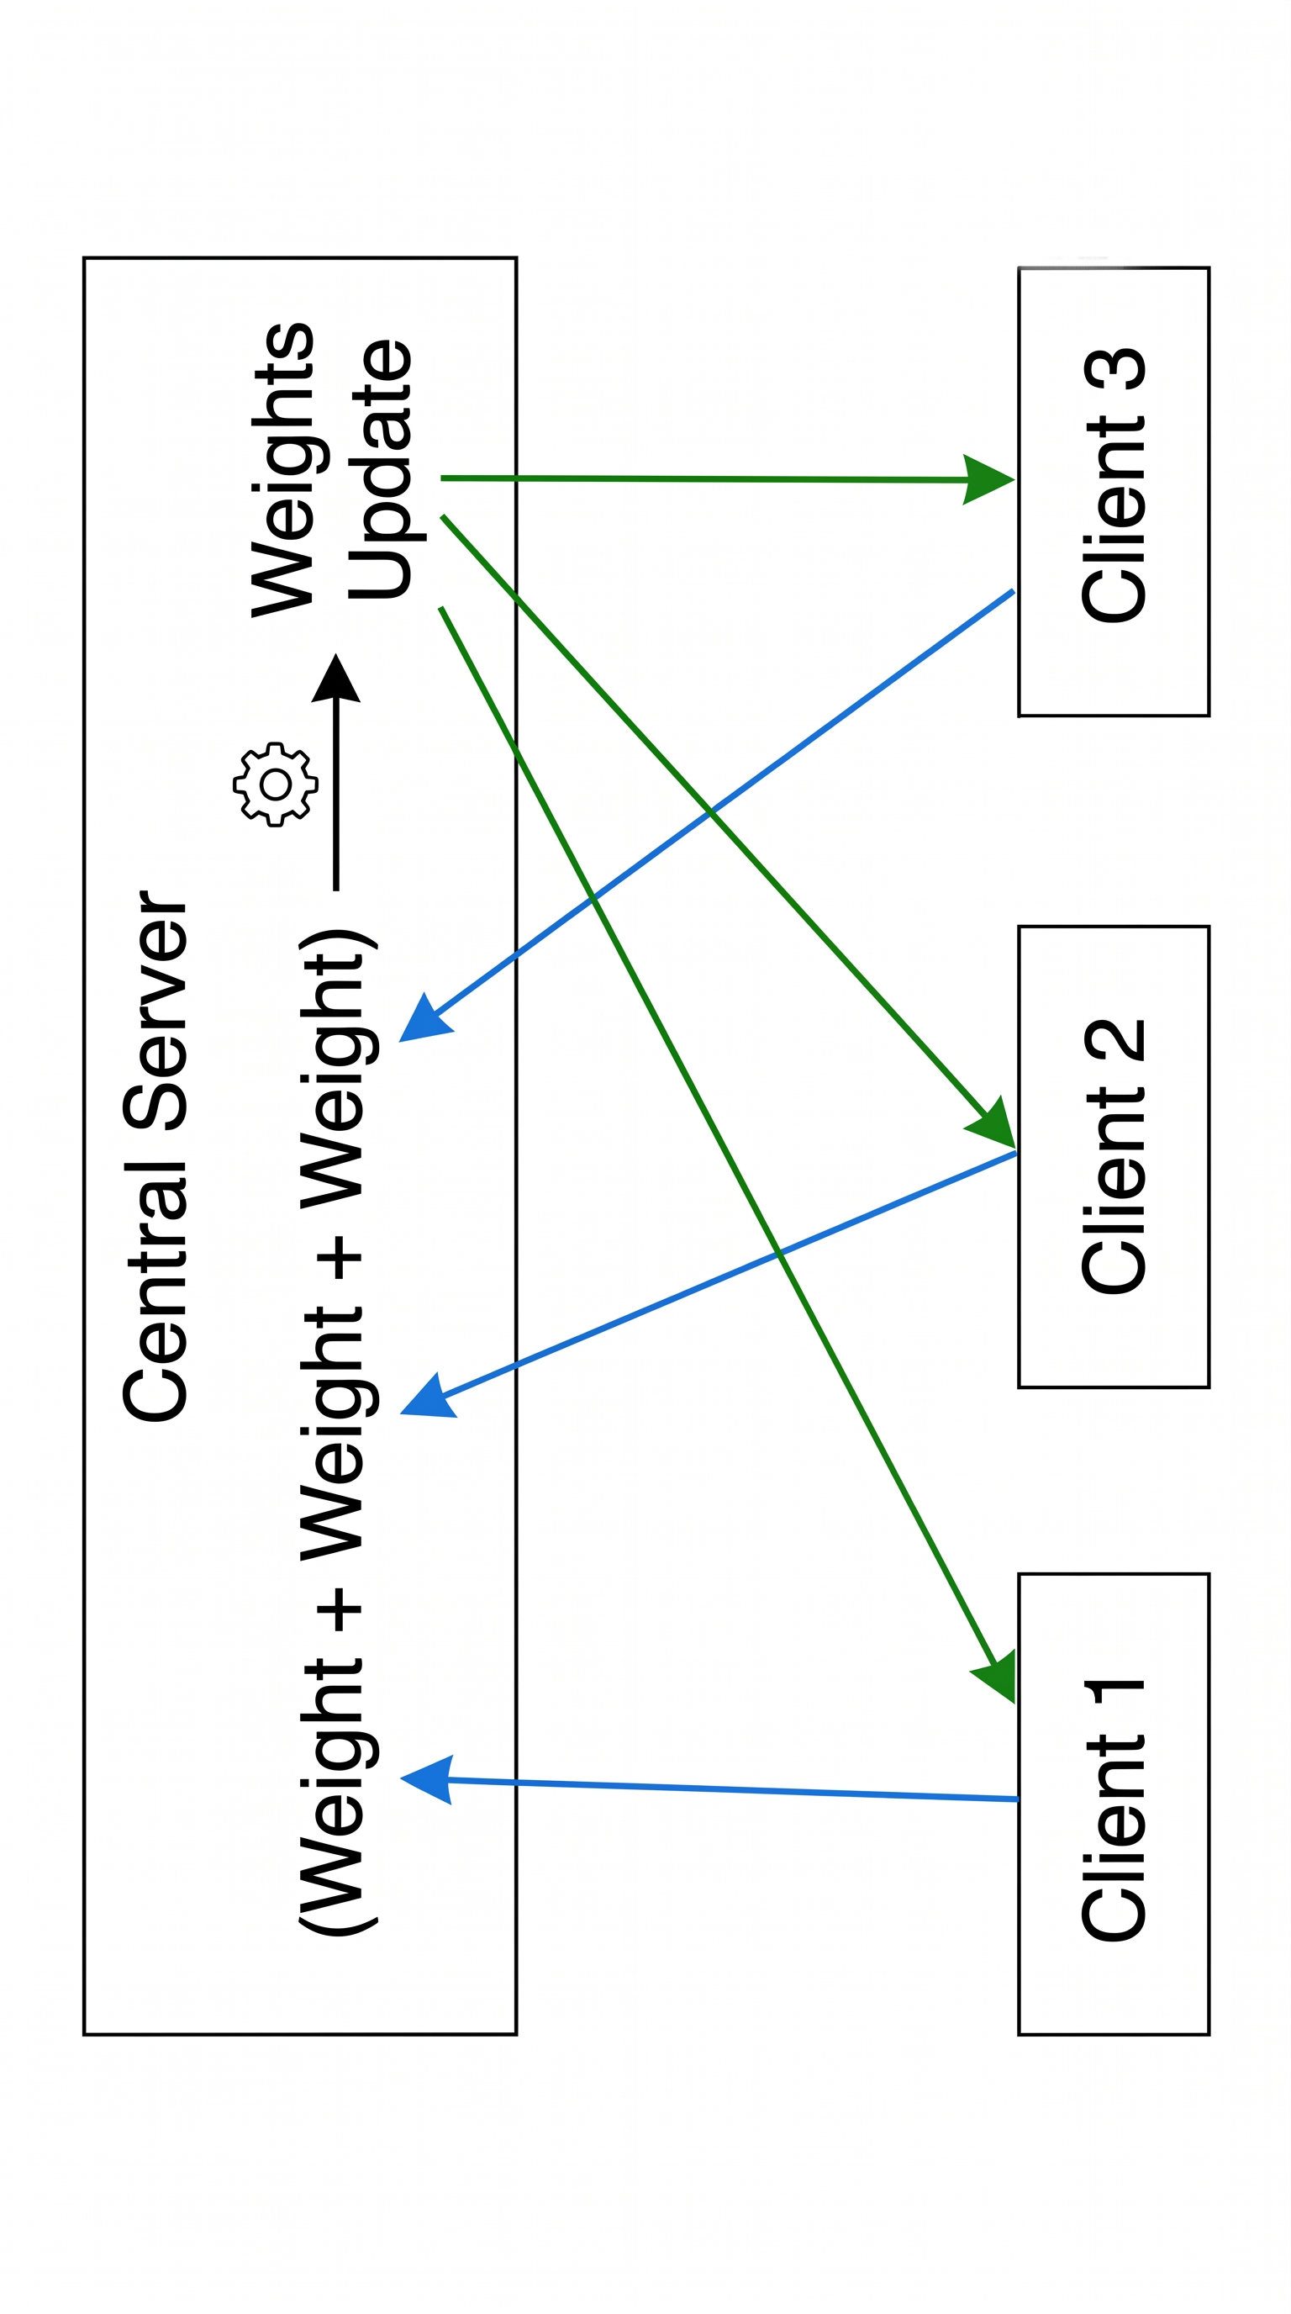

1.2 Literature Review
This section reviews five recent studies in the context of poisoning attacks and defenses in Federated Learning (FL). Each study is analyzed individually in terms of its core concept, results, and limitations, followed by a comparative table that summarizes their technical contributions and identifies the overarching research gap addressed by this project.
1. Defending Federated Learning from Collaborative Poisoning Attacks: A Clique-Based Detection Framework (Anastasiadis & Refanidis, 2025)
- Concept: This research proposes the Clique-Based Detection Framework (CBDF), which detects collaborative attackers by tracking the persistent similarity of final-layer weight updates across multiple rounds using Euclidean distance and graph clique detection.
- Results: The proposed method demonstrates superior performance in identifying synchronized adversarial groups, achieving an F1-Score of 0.84 and outperforming previous detection systems.
- Analysis & Gap: While highly effective in software-level detection, the study explicitly leaves the handling of identified malicious clients (e.g., model repair, exclusion, or network isolation) as future work. This project adopts the CBDF detection algorithm as its foundation and bridges its exact gap by engineering an automated network-level isolation mechanism.

2. SoK: Benchmarking Poisoning Attacks and Defenses in Federated Learning (Zhang et al., 2025)
- Concept: This paper introduces a comprehensive benchmark (FLPoison) that unifies the evaluation of 15 poisoning attacks and 17 defense strategies across various FL algorithms and data heterogeneity levels.
- Results: The extensive evaluation proves that while some defenses work under IID settings, almost no robust defense exists to effectively counter coordinated attacks under non-IID settings.
- Analysis & Gap: The study highlights a critical gap in the current landscape: existing defense mechanisms are entirely software-centric and do not provide an enforcement mechanism to disconnect or isolate compromised nodes from the network, leaving the system vulnerable to persistent attackers.

3. Model Poisoning Attacks to Federated Learning via Multi-Round Consistency (Xie et al., 2024)
- Concept: This study introduces "PoisonedFL," a novel model poisoning attack that bypasses current defenses by enforcing multi-round consistency among malicious clients using a fixed random sign vector and dynamic magnitude adjustment.
- Results: The empirical evaluation shows that PoisonedFL successfully breaks eight state-of-the-art defenses across five benchmark datasets.
- Analysis & Gap: The analysis proves that per-round filtering defenses are insufficient because they only weaken the attack in single rounds but cannot prevent its cumulative effect over time. This strongly emphasizes the necessity of proactively isolating malicious clients rather than merely filtering their updates.

4. Dual Defense: Enhancing Privacy and Mitigating Poisoning Attacks in Federated Learning (Xu et al., 2024)
- Concept: The authors propose a "Dual Defense" framework (DDFed) that combines Fully Homomorphic Encryption (FHE) for privacy with a cosine similarity-based anomaly detection mechanism for identifying poisoned encrypted models.
- Results: The framework successfully defends against Inner Product Manipulation (IPM), scaling, and ALIE attacks by filtering and excluding malicious updates from the aggregation group in each round, provided the attacker ratio is below 0.5.
- Analysis & Gap: Despite its effectiveness in round-by-round filtering, the framework lacks a proactive mechanism to permanently evict persistently malicious nodes. Attackers remain connected to the server, continuously consuming resources and attempting new exploits.

5. Federated Learning Models for Privacy-Preserving AI in Enterprise Decision Systems (Hasan, 2025)
- Concept: This study presents a systematic review based on the PRISMA framework, exploring FL as a privacy-preserving architecture in enterprise systems, focusing on secure aggregation and poisoning mitigation.
- Results: The research demonstrates that robust aggregation algorithms (e.g., FedProx, DP clipping) can successfully limit the influence of compromised updates and provide defense-in-depth.
- Analysis & Gap: However, the analysis reveals that robust aggregation often reduces statistical efficiency, particularly in non-IID (heterogeneous) data settings. Furthermore, it focuses entirely on software-level mitigation without addressing the physical or network-level eviction of malicious nodes.

Summary of Literature Review and the Research Gap:
The reviewed studies converge on a common limitation: detection and filtering mechanisms act exclusively on the model updates computationally, while the malicious clients remain physically connected to the FL network, continuing to consume resources and attempting cumulative attacks. Table 1 summarizes these studies and highlights the research gap that this project aims to resolve by adding a network-level enforcement layer. Study [1] was selected as the detection basis of this project, since it targets the coordination patterns that outlier-based defenses fail to capture. The gap identified in studies [1]–[5] is addressed by adding an enforcement layer at the network level.

Table 1: Comparison of Recent Studies on Poisoning Attacks and Defenses in FL
Ref. & Year | Paper Title | Core Mechanism | Evaluated Threats | Malicious Node Handling (Research Gap)
[1] 2025 | Defending Federated Learning from Collaborative Poisoning Attacks: A Clique-Based Detection Framework | Euclidean distance & Graph clique detection (CBDF) | Synchronized/ Collaborative Data Poisoning | Software-level detection only. Handling (exclusion/repair) is left as future work.
[2] 2025 | SoK: Benchmarking Poisoning Attacks and Defenses in Federated Learning | Comprehensive FLPoison benchmarking framework | 15 Data& Model Poisoning attacks across IID/non-IID | None. Proves current defenses lack mechanisms to disconnect persistent compromised nodes.
[3] 2024 | Model Poisoning Attacks to Federated Learning via Multi-Round Consistency | Attack methodology (Fixed random sign vector, dynamic magnitude) | Multi-Round Consistent Model Poisoning | Highlights gap: Shows that per-round filtering fails against cumulative effects, requiring proactive isolation.
[4] 2024 | Dual Defense: Enhancing Privacy and Mitigating Poisoning Attacks in Federated Learning | FHE (CKKS), Cosine similarity anomaly detection, DP perturbation | IPM, ALIE, and Scaling attacks | Round-by-round filtering. Excludes malicious updates computationally, but nodes remain connected.
[5] 2025 | Federated Learning Models for Privacy-Preserving AI in Enterprise Decision Systems | Systematic review of robust aggregation and DP clipping | General poisoning and backdoor threats | Algorithmic weight reduction. Reduces statistical efficiency in non-IID; no physical network isolation
1.3 Research Problem
The research problem lies in the gap between detecting coordinated malicious clients and removing their ability to participate in FL training. Its dimensions are as follows:
a. The “Blind” Aggregator Challenge: The central server receives model updates and never accesses the raw data [5]. Consequently, it cannot verify the integrity of the local data used by each client, and centralized oversight of client contributions is limited [1].
b. Coordinated Attacks (Sneaky Collusion): Cooperating malicious clients align their updates to mimic legitimate patterns, which allows them to bypass standard outlier-based detection [1]. The consistency of their updates across rounds further accumulates the attack effect [3]. In addition, the existing defenses show weak robustness under non-IID data [2].
c. Software-Level Mitigation Gaps: The reviewed defenses detect or filter malicious updates, but they do not remove the malicious clients from the network. The detection framework in [1] leaves the handling of identified clients as future work, and the framework in [4] excludes malicious updates from the aggregation of each round only. As a result, the attackers stay connected to the server and continue to consume its resources.
d. Cumulative Effect Across Rounds: Defenses that weaken the attack in individual rounds cannot prevent the accumulated effect of persistent malicious clients on the global model [3].
In summary, the problem addressed by this project is the absence of an automated mechanism that converts the detection of coordinated malicious clients into an enforced network-level response.

Figure 1.2: Block diagram of the research problem, illustrating the security gap where malicious clients remain actively connected to the network despite software-level anomaly filtering at the central server

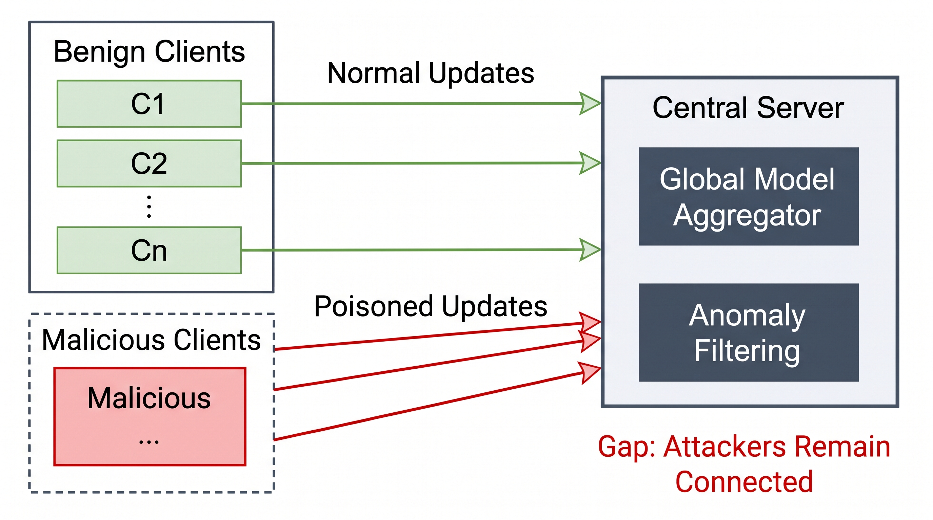

1.4 Proposed Solution
The proposed solution combines a detection algorithm with an automated network-level isolation mechanism. It consists of the following components:
a. Detection Algorithm (CBDF Framework): The Clique-Based Detection Framework (CBDF) proposed in [1] is applied as presented in the original study. The server computes the Euclidean distance between the final-layer weight updates of every pair of clients, records the K most similar clients of each client in every round, and counts how frequently each pair appears in each other’s top-K lists. Clients that exceed a coordination threshold are flagged, a graph of the flagged clients is constructed, and cliques of colluding clients are extracted. The detection threshold is then adjusted according to the clique size [1].
b. Automated Network-Level Isolation: The list of malicious clients produced by CBDF is used to cut off the attackers automatically through firewall rules on the server. This extends the detection result into a network-level response.
c. Final Outcome (Resource and Integrity Protection): Isolating the colluding clients aims to secure the global model and to prevent the exhaustion of server resources.
The solution is planned to be implemented on a multi-node simulated network. Python is used for the FL and CBDF logic, VMware and Ubuntu Linux for the server and edge nodes, Flask and REST APIs for the client-server communication, Snort 3 for network anomaly detection, and IPTables/UFW for the automated firewall isolation. The work is organized in three stages: network foundation and protocol configuration (Pre-Grad 1), FL setup and attack simulation (Graduation 1), and detection implementation with automated isolation (Graduation 2).

Figure 1.3: Architecture of the proposed solution, integrating the Clique-Based Detection Framework (CBDF) with an automated network firewall to enforce the physical isolation of malicious clients.
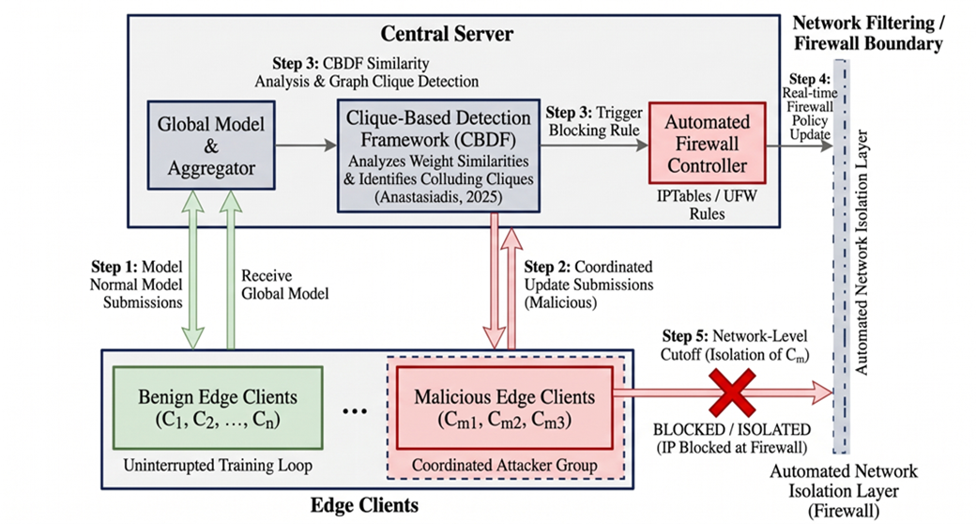

1.5 Research Objectives
This research seeks to achieve the following objectives: a. Building a Simulated FL Environment: Establishing a multi-node network composed of a central server and edge nodes, with the communication protocols required for FL training. b. Simulating Coordinated Poisoning Attacks: Reproducing synchronized data poisoning attacks by a group of colluding edge nodes in the FL environment. c. Detecting Colluding Nodes: Applying the CBDF framework [1] to identify the groups of clients that coordinate their updates. d. Automating Network-Level Isolation: Developing a mechanism that uses server firewalls to cut off the detected malicious nodes instantly after detection. e. Protecting Resources and Model Integrity: Securing the global model and preventing resource exhaustion by the isolated attackers.
The expected outcomes are securing FL against synchronized insider threats and the automated real-time isolation of malicious nodes.
.

1.6 Research Significance
The significance of this research is reflected in the following dimensions:
a. Protecting Critical Applications: FL is used in healthcare, finance, and autonomous driving, where the accuracy and robustness of the models are paramount, and where subtle manipulation can lead to serious consequences [1]. Securing FL against coordinated attacks supports its reliable use in such domains.
b. Moving from Detection to Enforcement: The research extends a detection framework [1] with an automated response, which addresses the limitation identified in the reviewed studies [1], [4].
c. Addressing Open Participation Risks: Attackers can inject fake clients into FL systems that allow open participation [3]. A mechanism that isolates such clients after detection adds a protection layer against this threat.
d. Supporting Enterprise Adoption: Enterprise decision systems depend on the integrity of FL models [5]. A defense that protects both the model and the server resources contributes to the secure deployment of FL in such systems.
1.7 Report Structure
This report is organized in five chapters. Chapter One presents the introduction, including the background, the literature review, the research problem, the proposed solution, the objectives, and the significance. Chapter Two presents the theoretical framework, including the basic definitions, concepts, algorithms, and protocols used in the project. Chapter Three describes the work environment, including the hardware, software, tools, and configuration settings. Chapter Four presents the proposed solution, including its methodology, algorithms, and protocols, supported by diagrams and tables. Chapter Five presents the comparisons and results, including the analysis of results and the comparison with previous studies. The report ends with a conclusion that summarizes the work and proposes future directions.
1.8 Chapter Summary
This chapter presented the background of FL and the poisoning threats that target it. The reviewed studies show that existing defenses detect or filter malicious updates, while the malicious clients remain connected to the system. The research problem was defined accordingly, and the proposed solution, which combines the CBDF detection algorithm with automated network-level isolation, was outlined together with the objectives and the significance of the research. The next chapter presents the theoretical framework of the project.

References
[1] M. M. Hasan, “Federated Learning Models for Privacy-Preserving AI in Enterprise Decision Systems,” International Journal of Business and Economics Insights, vol. 5, no. 3, pp. 238–269, 2025.
[2] H. Zhang et al., “SoK: Benchmarking Poisoning Attacks and Defenses in Federated Learning,” arXiv:2502.03801, 2025.
[3] D. Anastasiadis and I. Refanidis, “Defending Federated Learning from Collaborative Poisoning Attacks: A Clique-Based Detection Framework,” Electronics, vol. 14, no. 10, p. 2011, 2025.
[4] Y. Xie, M. Fang, and N. Z. Gong, “Model Poisoning Attacks to Federated Learning via Multi-Round Consistency,” arXiv:2404.15611, 2024.
[5] R. Xu, S. Gao, C. Li, J. Joshi, and J. Li, “Dual Defense: Enhancing Privacy and Mitigating Poisoning Attacks in Federated Learning,” in Proc. 38th Conference on Neural Information Processing Systems (NeurIPS), 2024.

